UTAH NATURE SECURITY
utahnaturesecurity.com
ETHICS COMPLAINT
Independent Legislative Ethics Commission
Utah Code § 36-12 et seq. | Utah Code § 20A-11-1604
Respondent: Scott D. Sandall, Utah State Senator, Senate District 1 (Box Elder County)
Updated May 2026 — Revised to reflect confirmed SB132 (2025) bill text and vote record

⚠ CONFIDENTIALITY NOTICE — READ BEFORE PROCEEDING
This complaint is confidential while under review by the Independent Legislative Ethics Commission. Any public disclosure — including on social media or to media — will result in automatic dismissal. Keep this document private until the Commission completes its review.

I. Complainant Information
This complaint is filed pursuant to Utah Code § 36-12-101 et seq. by two registered Utah voters with actual knowledge of the facts stated herein.

Complainant 1 — Full Legal Name: [FIRST NAME LAST NAME]
Address: [STREET ADDRESS, CITY, STATE, ZIP]
Phone: [PHONE NUMBER]

Complainant 2 — Full Legal Name: [FIRST NAME LAST NAME]
Address: [STREET ADDRESS, CITY, STATE, ZIP]
Phone: [PHONE NUMBER]

Date Filed: [DATE]

II. Respondent
Scott D. Sandall is a Utah State Senator representing Senate District 1, which encompasses Box Elder County — the county where the Stratos Project is located. He is a farmer and rancher by profession. He is subject to the Utah Public Officers’ and Employees’ Ethics Act and to the jurisdiction of the Independent Legislative Ethics Commission.

III. Statement of Facts

A. The Stratos Project
The Stratos Project (also called Wonder Valley Utah) is a proposed 40,000-acre hyperscale AI data center and natural gas power campus in Hansel Valley, Box Elder County, Utah — larger than Washington D.C. It was approved by the Military Installation Development Authority (MIDA) on April 24, 2026, and by the Box Elder County Commission on May 4, 2026. The project’s signature feature is a closed private natural gas generation system designed to produce up to 9 gigawatts of power — more than double Utah’s entire current consumption — operating independently of Rocky Mountain Power.

B. SB132 (2025) — The Electricity Law That Made Stratos Possible
Senator Sandall was the chief sponsor of SB 132, Electric Utility Amendments, during the 2025 Utah General Session. House Sponsor: Colin W. Jack. Signed by Governor Cox on March 25, 2025. Effective May 7, 2025.

What SB132 Actually Does — Official Bill Text
"This bill creates requirements for providing electrical service to large-scale electrical loads."
Specifically, SB132:
- Creates a new legal framework (Utah Code Title 54, Chapter 26) for customers with electrical demands of 100 megawatts or more — targeting exactly the scale of a hyperscale data center or AI campus
- Authorizes “closed private generation systems” — self-contained power plants operating independently of Rocky Mountain Power’s monopoly grid. The Stratos Project’s 9-gigawatt natural gas campus is precisely this structure.
- Allows large load energy consumers to enter flexible contracts with alternative energy providers outside the utility’s regulated rate structure
- Exempts service provided under this framework from certain rate regulation requirements, maintaining only safety and reliability standards
- Time-limited to service contracts commencing by December 31, 2034 — a window that covers the entire projected Stratos buildout timeline
Source: Enrolled SB0132, Utah 2025 General Session — le.utah.gov/Session/2025/bills/enrolled/SB0132.pdf

In plain terms: before SB132, a 9-gigawatt self-contained natural gas power plant operating outside Rocky Mountain Power’s monopoly had no clear legal home in Utah utility law. SB132 created that legal home. Without it, the Stratos Project’s power model — the core of the entire development — could not have been structured as it was.

⚠ THE CORE CONFLICT
Senator Sandall sponsored SB132 (2025) — the bill that created the legal framework for a 100+ megawatt closed private generation system to operate in Utah outside Rocky Mountain Power’s monopoly — while representing Box Elder County, where the Stratos Project is located, and while owning land approximately 4 miles from the proposed Stratos site. He did not disclose his land ownership in connection with this legislation. The bill passed the House 71-0 and the Senate 27-0. Zero legislators voted no.

C. The Vote Record — SB132 Final Passage
SB132 passed both chambers with zero nays — the most lopsided possible outcome, suggesting the bill was presented as uncontroversial utility modernization rather than as infrastructure enabling a specific 9-gigawatt project. The vote images below are the official Utah Legislature records.

House of Representatives — Final Passage, March 7, 2025 (71-0):
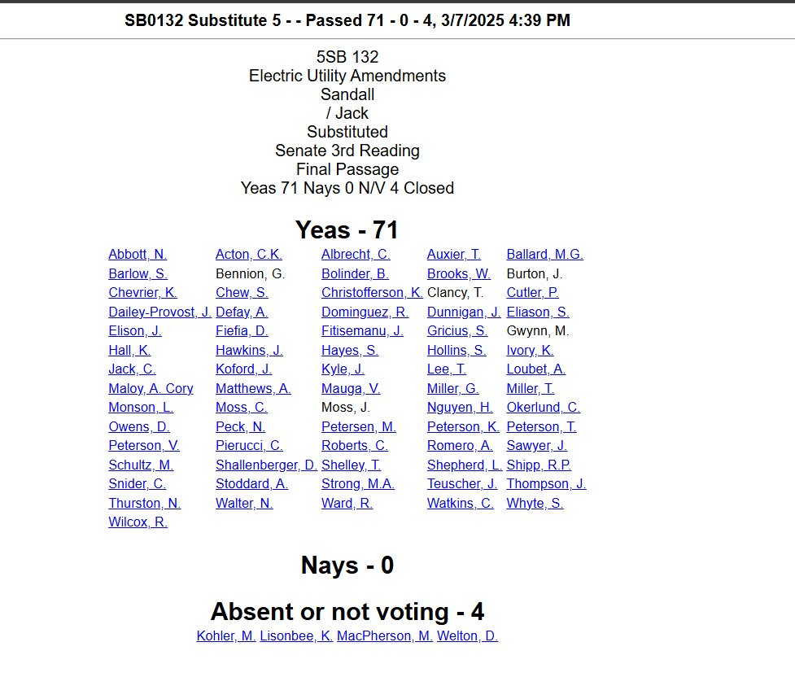
SB0132 House Final Passage — 71 Yeas, 0 Nays, 4 Absent — March 7, 2025, 4:39 PM. Schultz, M. voted Yea. Source: Utah Legislature official vote record.

Senate Concurrence with House Amendment — March 7, 2025 (27-0):
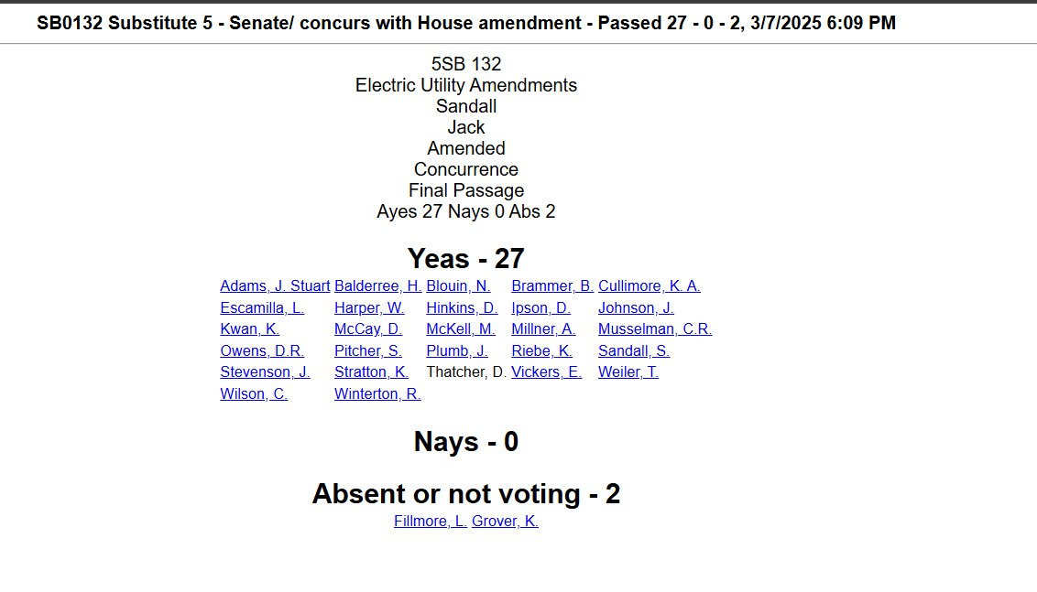
SB0132 Senate Concurrence — 27 Yeas, 0 Nays, 2 Absent — March 7, 2025, 6:09 PM. Sandall, S. (bill’s own sponsor) and Adams, J. Stuart both voted Yea. Source: Utah Legislature official vote record.

Who Voted on SB132 — And What They Have to Gain
Sandall, S. — Voted YEA on his own bill.
The bill’s chief sponsor voted in favor of his own legislation creating the legal framework for 100+ MW closed private generation systems — while owning land 4 miles from the project that would use exactly that framework.
Schultz, M. — Voted YEA (House).
The House Speaker who owns 25,000+ acres surrounding the Stratos Project voted to pass the law enabling the project’s power infrastructure.
Adams, J. Stuart — Voted YEA (Senate).
The Senate President who later chaired the MIDA Stratos approval and received $135,000 in PAC donations 7 days afterward voted in favor of the electricity bill that made the project’s power model legally viable.

D. Senator Sandall’s Land Near the Stratos Project
Public records and reporting by ABC4 News confirm that Senator Sandall’s Sandall Farm & Ranch Family Partnership holds land approximately 4 miles from the proposed Stratos Project site in Box Elder County. The map below — published by Elevate Utah — shows his land (purple) in relation to the Stratos site (red) and Speaker Schultz’s holdings (yellow):

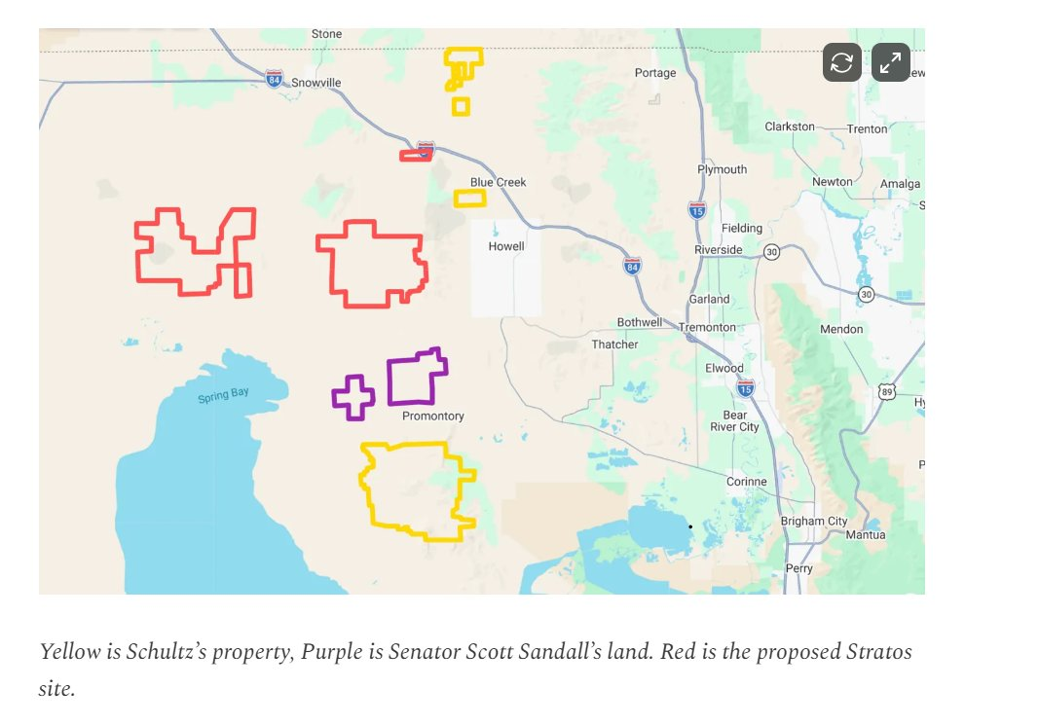
Yellow = Speaker Schultz’s property. Purple = Senator Sandall’s land. Red = proposed Stratos site. Source: Elevate Utah (elevateutah.news) via Box Elder County records.

When asked by ABC4 News whether anyone had approached him about selling his land, Senator Sandall confirmed he had not yet been contacted — and then said this:

"He said he had not been contacted — but that he would not be opposed to it, for the right price."
— Senator Scott Sandall, as reported by ABC4 News

This is Senator Sandall’s own statement on record. He wrote the law that made the project’s power model viable. He represents the county where it sits. He owns land 4 miles away. He publicly confirmed he would sell that land at the right price.

E. The Two-Bill Pattern — Electricity and Approval, Both from Sandall’s District
The Stratos Project required two distinct legal enablements to proceed:

- Power infrastructure: SB132 (2025) — created the legal framework for 100+ MW closed private generation systems operating outside Rocky Mountain Power. Sponsored by Sandall. Signed May 7, 2025.
- Land use and approval authority: MIDA’s expanded project area authority under existing and updated statutes — which allowed a quasi-governmental board chaired by Senate President Adams to approve the 40,000-acre project without normal county zoning processes.

Sandall authored the electricity half. His Senate President authored and chaired the approval half. Between them, the two most significant legislative enablements for the Stratos Project were shepherded by officials with undisclosed land interests in the project area.

F. Failure to Disclose
Utah Code § 67-16-10 requires legislators to disclose potential conflicts of interest before taking legislative action in which they have a personal financial interest. Senator Sandall sponsored SB132, which created the legal power infrastructure framework that the Stratos Project is built upon — in the county he represents, near land he owns — without disclosing his Box Elder County land holdings as a potential conflict of interest.

Research documented by LandApp and CBRE confirms that land near hyperscale data center developments appreciates 2–4 times agricultural values in rural areas, and up to sixteen times in mature corridors. Senator Sandall has publicly acknowledged he would sell his land for the right price. That financial interest was not disclosed when SB132 was introduced, debated, or passed.

IV. Legal Basis
- Utah Code § 67-16-5 — Prohibition on using a public position to obtain personal financial benefit. Senator Sandall used his Senate position to sponsor SB132, which created the specific legal framework enabling the Stratos Project’s 9-gigawatt closed private generation system — near land he personally owns in Box Elder County. The legislation directly enhanced the development feasibility and land value of property he holds in the project area.
- Utah Code § 67-16-10 — Failure to disclose a conflict of interest before taking legislative action. Senator Sandall did not disclose his Box Elder County land holdings or potential financial benefit when sponsoring SB132 or in connection with any related legislative activity.
- Utah Code § 20A-11-1604 — Conflict of interest disclosure requirements. The disclosure regime exists to make potential overlaps between private interests and public power visible before decisions are made. Senator Sandall’s land holdings, combined with his authorship of SB132, his representation of Box Elder County, and his stated willingness to sell constitute exactly the conflict the system was designed to surface.
- Utah Senate Rules — Conflict of Interest. Senator Sandall should have either recused himself from SB132 or publicly disclosed his Box Elder County land holdings before sponsoring the bill. He did neither.

V. Relief Requested
- Investigate whether Senator Sandall’s ownership of land approximately 4 miles from the Stratos Project site constituted an undisclosed conflict of interest in connection with his sponsorship of SB132.
- Investigate whether Senator Sandall was aware of the Stratos Project or discussions about large-scale data center or power development in Box Elder County prior to or during the SB132 drafting and legislative process.
- Investigate whether any person associated with the Stratos Project, O’Leary Digital, West GenCo, MIDA, or related interests communicated with Senator Sandall about SB132, his land, or the project’s power needs before or during the 2025 legislative session.
- Require full public disclosure of all real property interests held directly or indirectly by Senator Sandall in Box Elder County and the surrounding project area, including Sandall Farm & Ranch Family Partnership holdings.
- Consider appropriate sanctions if violations are found, including censure, limitation of legislative privileges, or referral for further action.
- Recommend that Utah Senate rules be amended to require disclosure of real property and business holdings that may be materially affected by legislation a senator sponsors, particularly when the legislation creates new legal frameworks for specific industries or development types.

VI. Resources — Verify the Facts Yourself
At least one complainant must have actual knowledge of the facts before signing. That means personally verifying the records — not just reading about them. Use the sources below. Spend 15–30 minutes verifying before signing.

SB132 — Primary Source
SB132 Enrolled Bill (2025 Utah General Session) — Full Text
le.utah.gov/Session/2025/bills/enrolled/SB0132.pdf
The actual enrolled text of SB132. Read Part 3 (Sections 54-26-301 through 54-26-302) to confirm the “closed private generation system” provision. This is what enables a self-contained power plant outside Rocky Mountain Power’s grid.
Utah Legislature — SB132 Bill Page with Status and Votes
le.utah.gov/~2025/bills/static/SB0132.html
Official Utah Legislature page for SB132. Confirms Sandall as chief sponsor, Jack as House sponsor, vote tallies (House 71-0, Senate concurrence 27-0), and Governor Cox’s signature on March 25, 2025.
Utah House Press Release — Ceremonial Signing of SB132
house.utleg.gov/utah-leaders-celebrate-landmark-energy-legislation-to-power-utahs-future/
Official House press release confirming SB132 “modernizes Utah’s energy framework by allowing large load energy consumers — those needing 100+ megawatts — to enter into flexible contracts with existing utilities or alternative energy providers.”

Primary Investigative Reporting
Elevate Utah — “The Call Is Coming From Inside The Statehouse” (May 14, 2026)
elevateutah.news/p/the-call-is-coming-from-inside-the
Original reporting identifying Sandall’s land near the Stratos site, alongside Schultz’s holdings. Includes the parcel map and the ABC4 quote about his willingness to sell. Read this first.
ABC4 News — Sandall Quote on Selling His Land
abc4.com/news/northern-utah/box-elder-county-commissioner-speaks-data-center-vote/
Contains Senator Sandall’s on-record statement that he would not be opposed to selling his land near the Stratos Project, for the right price. Watch or read to establish actual knowledge of this quote.
Stateside Associates — 2025 Utah Session Takeaways (SB132 analysis)
stateside.com/blog/2025-state-legislative-session-takeaways-utah
Third-party legislative analysis confirming SB132’s purpose: “creates an alternative process for large energy users to negotiate power contracts outside of Rocky Mountain Power’s monopoly.”

Public Records to Verify Yourself
Sandall Conflict of Interest Disclosure
disclosures.utah.gov — search “Scott Sandall”
Review his annual disclosure. Confirm that his Box Elder County land holdings are not disclosed as a potential conflict in connection with SB132 or the Stratos Project.
Box Elder County Parcel Map (Web GIS)
beco.maps.arcgis.com/apps/instant/basic/index.html?appid=decfc0e5a98e4827bd4fea72ea260f32
Interactive parcel map. Search for Sandall Farm & Ranch Family Partnership to see the parcel boundaries relative to the Stratos Project corridor.
MIDA Board Meeting Highlights — April 24, 2026
midaut.org/news-2/mida-board-meeting-highlights
Official MIDA summary confirming the unanimous Stratos approval. The project approved here is the one whose power infrastructure SB132 legally enabled.

Where to File
Independent Legislative Ethics Commission
ethics.utah.gov/independent-legislative-ethics-commission/
Find the current mailing address and filing checklist. Mail only — original ink signatures required. No email accepted. Enclose six copies of each exhibit.

VII. Certification and Signatures
The undersigned complainants, being registered voters in the State of Utah, hereby certify that:

- The facts stated herein are true and correct to the best of our knowledge.
- We have actual knowledge of the facts stated, having personally verified the underlying public records referenced in this complaint.
- We understand this complaint is confidential while under review and will not disclose its existence publicly until the Commission completes its review.
- We submit this complaint in good faith for the lawful purpose of seeking accountability for potential ethics violations by a public official.

Complainant 1 Signature: __________________________________________________
Printed Name: [FIRST NAME LAST NAME]
Date: [DATE]

Complainant 2 Signature: __________________________________________________
Printed Name: [FIRST NAME LAST NAME]
Date: [DATE]

MAIL TO — original ink signatures required, no email accepted:
Independent Legislative Ethics Commission — ethics.utah.gov/independent-legislative-ethics-commission/
Enclose six (6) copies of each exhibit. Do not discuss this filing publicly while under review.

Investigative reporting by Elevate Utah — elevateutah.news
Utah Nature Security — utahnaturesecurity.com — Updated May 2026

